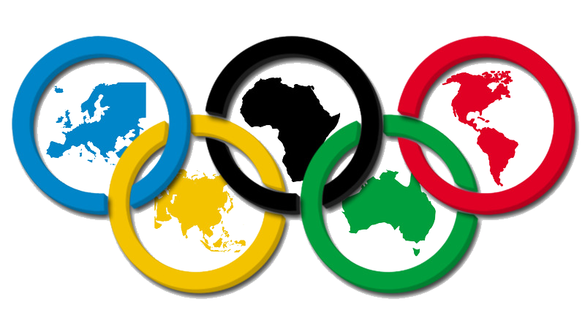

**OLYMPIC DASHBOARD REPORT :**

**Overview:**

**The Power BI Olympic Dashboard for the years 1896 to 2016 provides a comprehensive and interactive visualization of Olympic Games data over a span of over a century. This dashboard is designed to offer insightful analytics and trends, making it a valuable resource for sports enthusiasts, researchers, and analysts.**

**KPIs :**

1. **Top 10 Countries by Medals**

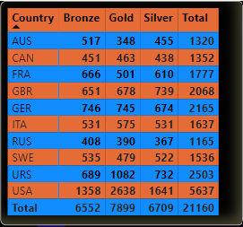

1. **Medals Won by Gender %**

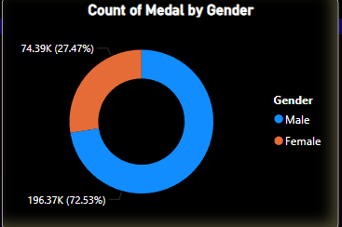

1. **Male and Female ratios by Year**

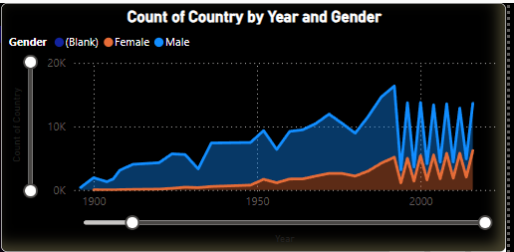

1. **Top 10 Medallists by Medals**

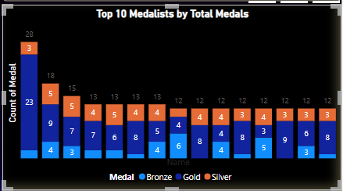

1. **Total Number of Participating Countries**

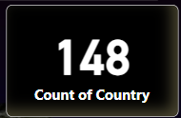

1. **Total Numbers of Sports**

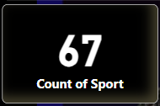

**Use Cases:**

* **Historical Research: Ideal for historians and researchers studying the evolution of the Olympics.**
* **Sports Analysis: Useful for sports analysts assessing trends and performance metrics.**
* **Educational Purposes: A resource for educators and students exploring the history and impact of the Olympics.**

**This Power BI Olympic Dashboard is a powerful tool for uncovering the rich history of the Olympic Games, offering a visually engaging and informative experience.**